1. INTRODUCTION

1.1 Overview

The global air transportation network network is a comprehensive colletion of information on airports, airlines and their routes.

It contains information such as names, cities, countries, longitudes, latitudes and altitudes time zone and daylight saving time data.

1.2 Purpose

Air transport allows people from different countries to cross international boundries and travel other countries for personal, business, medical and tourism purposes.

They also prove to be extremely useful during the times of natural calamities, wars and other emergencies.

2. Problem Definition and Design Thinking

2.1 Empathy Map

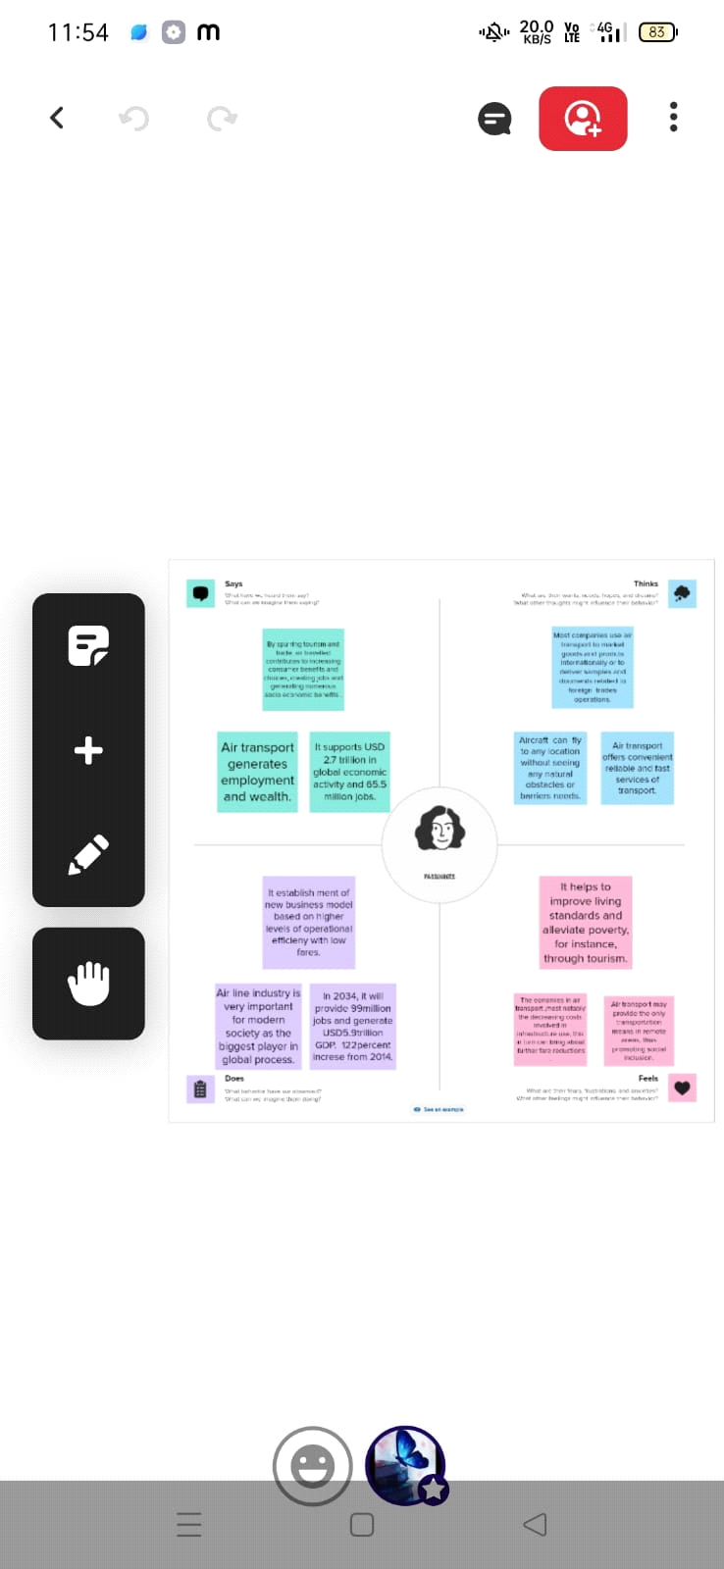

2.2 Ideation and Brainstorming Map



3. RESULT

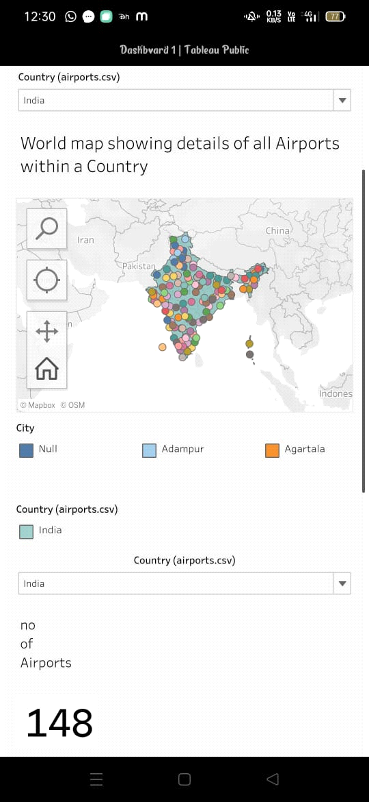

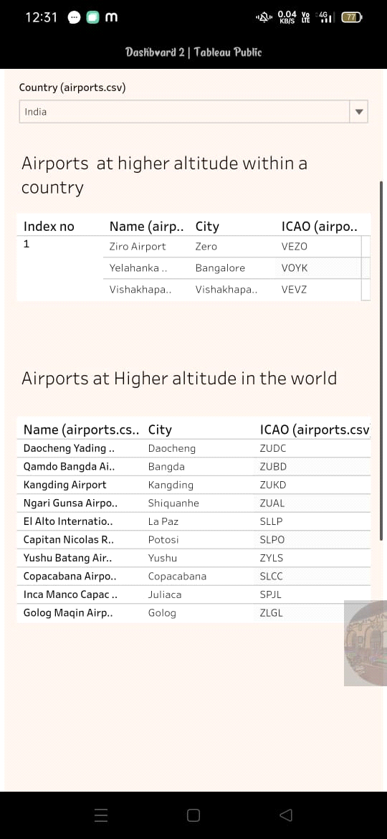

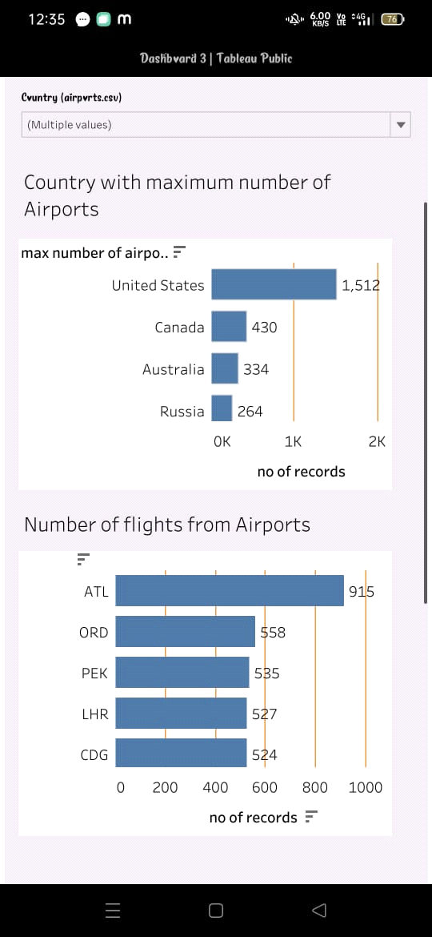

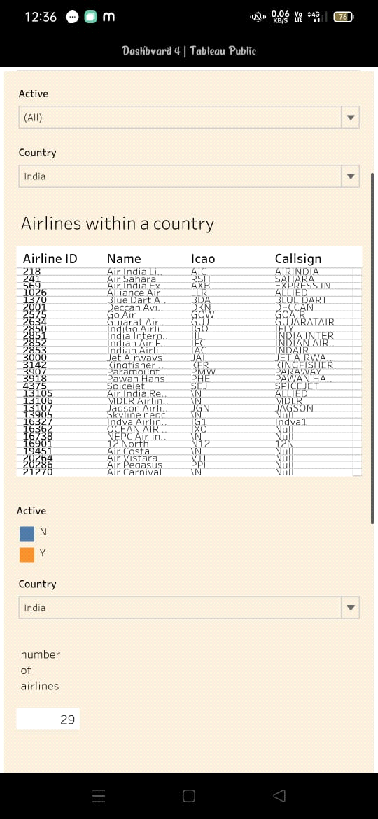

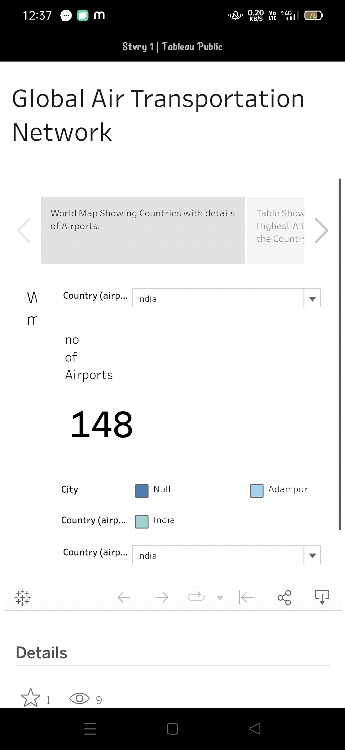

4. ADVANTAGES AND DISADVANTAGES

1) Advantages

Workers can code software in one part of the world and pass to a company thousands of miles away that will assemble.

Aware of different cultures and labour conditions and that these practices can foster unfare competitive advantages, which they do not want to support.

2) Disadvantages

Labour shortage reached an all time high, with airlines laying off thousands off employees due to fund shortage, and many others, includings pilots, quitting due to job insecurity and fear of the pandemic.

According to DGCA, when Indian airlines suspended operations for six days it led to a 33% decline in passenger traffic.

5. APPLICATIONS

EasyJet, British airways, air France and Lufthansa are the airlines industries which undergoes labour shortage.

It is possible to streamline their flight planning, crew scheduling, maintenance tracking, aircraft dispatch, and other processes.

These were the applications of our solution.

6. CONCLUSION

International air transport is less than a century old, but is now a major contributor to globalization and is continually reshaping itself to meet the demands of the economic and social integration that globalization engenders. Economically, in static terms, globalization occurs to facilitate the greater division of labour allows countries to exploit their comparative advantage more completely.

7. FUTURE SCOPE

Costs must be controlled, productivity must be improved and security enhanced.

And all of this must be done at the same time as meeting the increased expectations of passengers for smooth and efficient services which ensure hassle free travel.